Data Communication and Network
LAB

FAROOQ AHMAD Experiment #12
17L4407 Lab Report # 11
BEE-5A

BUILDING A NETWORK IN GRAPHICAL NETWORK SIMULATOR 3 (GNS3)

INTRODUCTION
In this lab session, we were introduced to building a network on graphical network simulator 3 (gns3). Graphical Network Simulator 3 or GNS3 is a network software emulator that is used to build complex networks. It allows the combination of virtual and real devices, used to simulate complex networks. It uses Dynamips emulation software to simulate Cisco IOS. Moreover we were introduces to the Dynamic Host Control Protocol in GNS-3. A DHCP server is used to automatically provide IP addresses to clients. In this lab, you will configure a Dynamic Host Configuration Protocol (DHCP) server and two clients. It is a way to dynamically allocate IP address to the PC’s on run time. The server automatically assigns the next available IP address to the PC.

OBJECTIVE

The course learning objective of this lab session was to
• Implement the Dynamic Host Control Protocol in GNS-3
• Under the concept of subnet

DESIGN PROCEDURE
You have to design a network solution for the Fast-NU Labs, Staff and Faculty members. Labs, Staff and faculty members should be on different Sub networks. There are total 50 computers divided in this way Staff 6, Faculty 4, and each lab contains 10(There are 4 Labs)

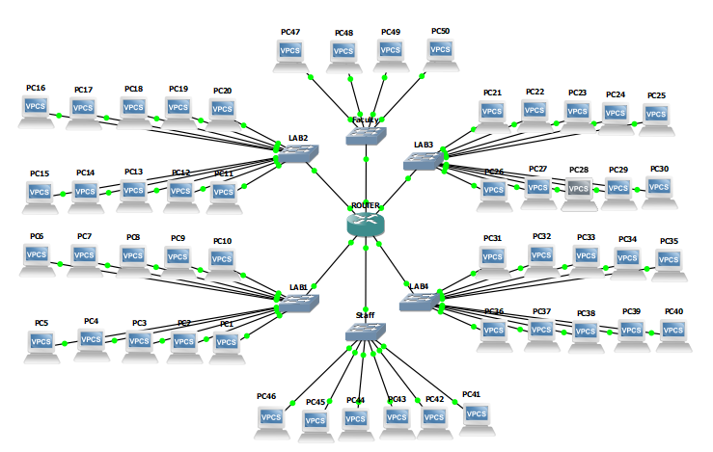
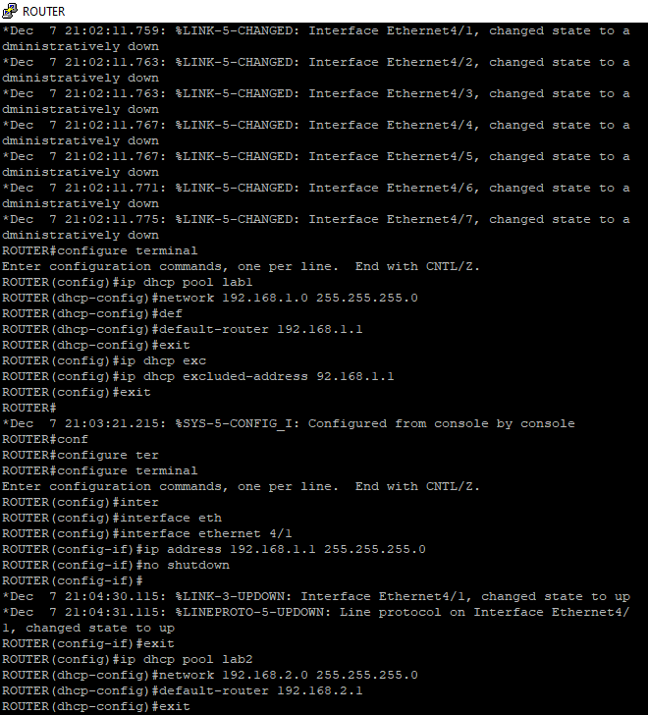
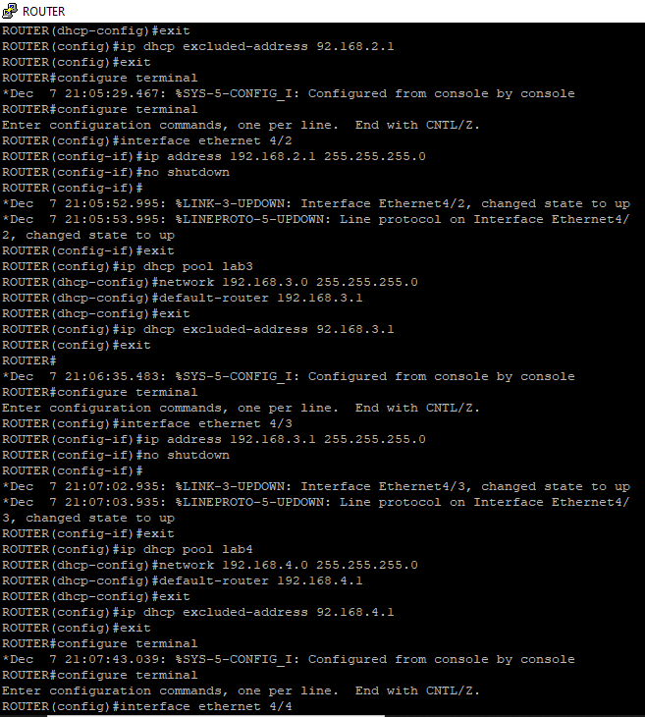
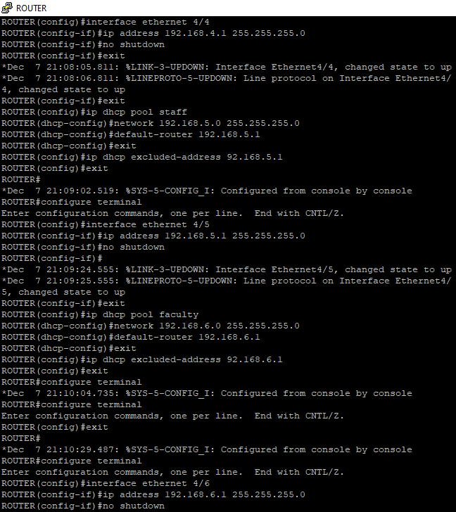
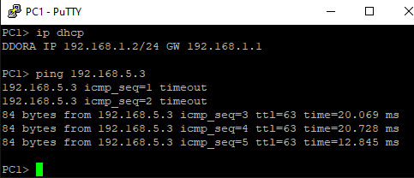
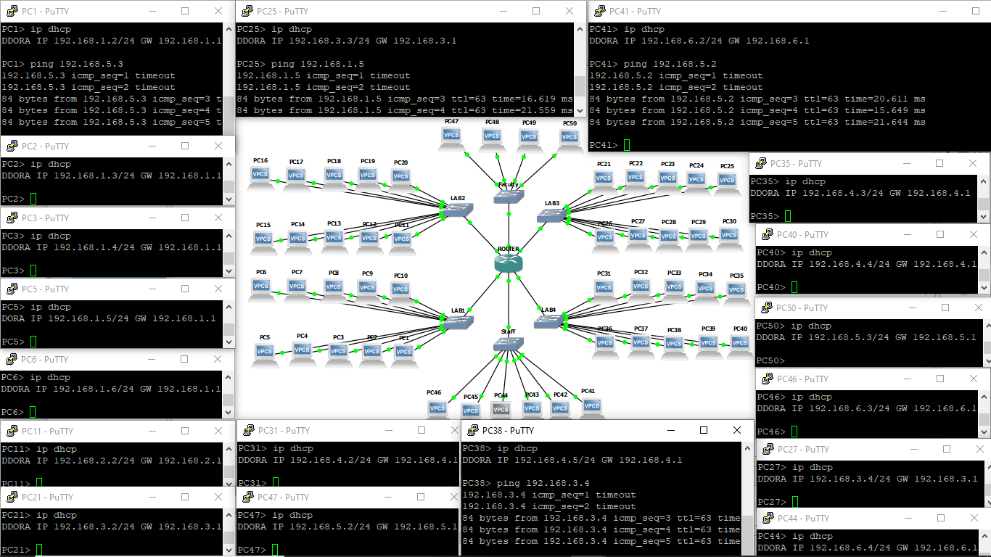

ISSUES
There were as such none issues.

CONCLUSION
This lab session was conducted successfully. From this experiment activity, we learned how to use Graphical Network Simulator (GNS-3) to simulate a network topology. Moreover, we made a complex network topology and learned how IP assignment works in real world networks. In addition to that, we also learned about the Dynamic Host Control Protocol. The DHCP assigns IPs addresses to available devices on the network, and monitors the time for which each of these devices are active, so that there is no collision of IP addresses.

APPLICATIONS
GNS-3 is a useful tool for network engineers to test our designed devices, as it allows us to make use of other real world’s devices and monitor their behavior. Moreover, it is used as learning tool, to help understand students networking in a user friendly way. DHCP (dynamic host configuration protocol) is used for dynamically assigning network addresses to hosts. DHCP operates on a client-server model, where a DHCP server sends configuration information to DHCP clients. The CCNA (Cisco Certified Network Associate) exams require you to understand DHCP and be able to configure and verify it on Cisco routers.

POST LAB
Question
What DORA stands for? Using a timeline diagram, show an example of a client getting its IP address from DHCP server.
Answer
DORA stands for Discover, Offer, Request, and Acknowledgement. It is a process in which the DHCP that assigns IP addresses to clients.
DHCP job is to assign IP address to the client when client request DHCP server.
It contains 4 steps to get IP address from DHCP server.
Step 1: Client sent broadcast (255.255.255.255) message to the network.
Step 2: DHCP server in the network will reply with an IP lease. It uses broadcast address but the frame contains MAC address of client. So only the requested client will get that packet. It may receive more than one packet from different DHCP servers. But usually client will use the first one it gets.
Step 3: Then client will send DHCP request to the DHCP server that it sends the offer.
Step 4: The DHCP server will send back an acknowledgement to the client.
